All persons using this substance must be provided with basic information on usage precautions.
As a minimum requirement they should have a copy of this assessment in a readily accessible location.

This Assessment must be accompanied by the relevant Safety Data Sheet (SDS)

Company name:
Address:
Name of Substance:
Also known as:
Assessment date: | Click here to enter a date. | Assessment No:
Optional Information
(No. of users, CAS numbers etc.):
MSDS date: | Click here to enter a date. | Assessed by:

Emergency Exposure and Treatment Information:
General Risk Level:
Contact with Skin:
Contact with Eyes:
If Inhaled:
If Swallowed:
Spillage Action:
Fire Action:
Extinguisher(s)

Hazards:
 |  |  | Toxic |  |  |  |  | Health Effect |  |  |  |  |  | Irritant/Harmful
 |  |  | Flammable |  |  |  |  | Explosive |  |  | 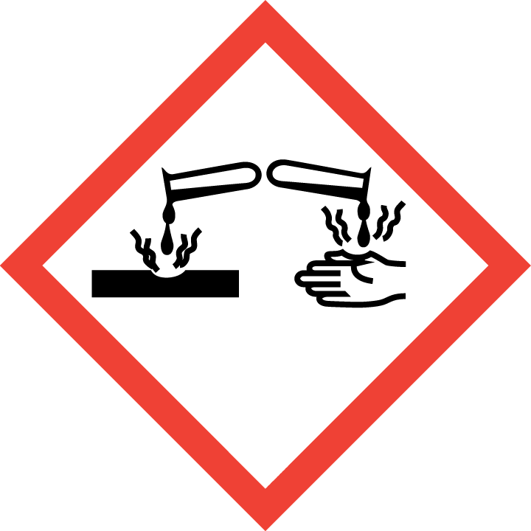 |  |  | Corrosive
 |  |  | Danger to the  environment |  |  | 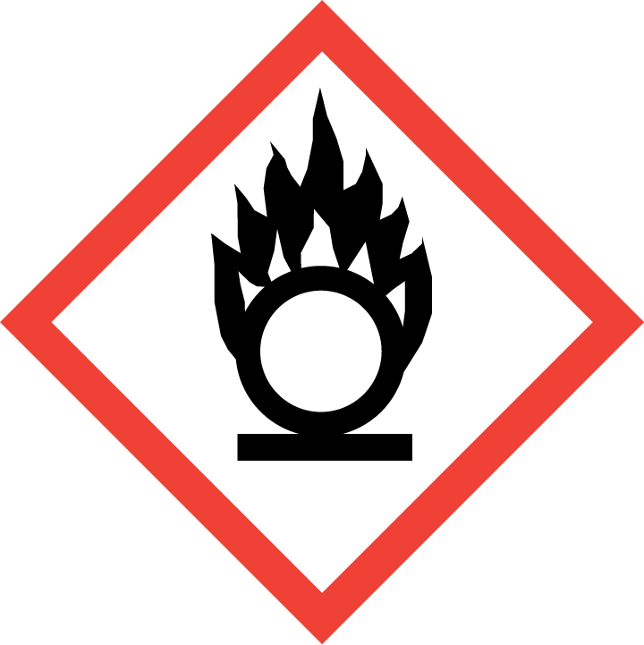 |  | Oxidiser |  |  |  |  |  | Pressurised Gas
 |  |  | Non-hazardous |  |  | Other:
Users: Who should not use this chemical?
 | Expectant and Nursing Mothers |  |  |  | Young Person(s)  (under 18 years) |  |  |  |  | Asthmatic |  |  |  |  | Sensitised
Other:
Storage: How should this chemical be stored?
 | Locked away for restricted users |  |  |  | Chemical Cupboard |  |  |  |  | Lid Sealed |  |  |  |  | Ventilated Area
Other:

Controls on Usage:
Usage Type:
Description of Process:
Potential Routes of Entry:
Process Controls:
Closed Extraction Booth (LEV)
Open Extraction Booth (LEV)
Well Ventilated Area
(e.g. by window or use of fans)
Non-enclosed Space
(e.g. normal working areas)
Restricted Chemical
(e.g. expertise required)
Enhanced training required
Other Process Control Notes:
PPE Controls:
   |  |  | Respiratory Protection:
   |  |  | Eye Protection:
 | Hand Protection:
 | Skin Protection:
 | Other PPE Control Notes:
Monitoring Controls:
Exposure Monitoring
Other Monitoring Control Notes:
General Usage and Disposal Guidance:
 |  | Keep from naked flame |  |  | Keep from sources of ignition |  |  |  | Keep out of direct sunlight |  | Keep away from heat
 |  | Store away from drains |  |  | Do not throw in bin |  |  |  | Wash hands after use
Stability:
Waste Disposal:
Used Wipes etc.
Notes / Comments:

For office use only – Document ref. no.: | v1.

